[Organisation] · PHASE C
Data Architecture Blueprint
Current state, target state, and the fourteen data building blocks that close the distance
Field | Detail
Version | 0.1 — Draft
Date | August 2027
Owner | Data Domain Architect (vacant — held by the Chief Enterprise Architect)
Approver | Data Governance Council, then Architecture Board
Source | Gaps from metamodel O29 and work packages from O30, filtered to the Data domain. Current and target state summarised from the Phase C artifacts. Building blocks are defined here and should be added to the metamodel under CR-034.
Classification | Internal

1. Current state
As at August 2027. Each row references the Phase C artifact that holds the detail; nothing is restated here.

Layer | Position | What it means
Entities | 24 concepts, 11 subject areas, all named and defined by the business. | 3 have no logical component.
Structure | 12 logical components, 6 of them Target. 18 physical stores on 5 technologies. | 3 logical components have no physical store.
Mastering | 44 Master relationships across 26 applications. 10 entities sourced from more than one. | Party and Customer from 5 each, all contested.
Movement | 50 recorded interfaces, 44 unmanaged, 20 batch files, 4 direct database reads. | Register is 83% complete against an estimated 60.
Quality | Poor on 4, Fair on 14, Good on 6. | A judgement. Nothing measures quality anywhere.
Lifecycle | Create 18, Validate 8, Use 17, Maintain 11, Archive 5, Dispose 0. | 24 retention obligations, no disposal.
Security | 4 Restricted, 17 Confidential, 3 Internal. 8 controls, 3 absent. | Restricted data reached by role, never by named individual.
Metadata | 22 elements, 10 held in full, 7 absent including lineage. | 14 elements held in a spreadsheet.
Traceability | 11 of 24 concepts trace from business definition to data set. | 13 break at five different points.

2. Target state
The same nine layers, with the building block that closes the distance named in the last column.

Layer | Target | Closed by
Entities | Every concept placed, stored, sourced and consumed, or recorded as operational only. | DBB-04, DBB-05
Structure | The three target components built: product catalogue, conduct record store, regulatory reporting store. | WP-06, WP-08, WP-16
Mastering | One designated source per entity. Identity resolved across four masters without replacing any. | DBB-01, DBB-02, DBB-03
Movement | Every new interface on the managed layer. The four direct database reads removed first. | DBB-12, ABB-04
Quality | Measured against stated rules for every entity carrying a regulatory obligation. | DBB-10
Lifecycle | Disposal implemented for every entity with a retention obligation. | DBB-07, which has no work package
Security | Named-individual access for Restricted, with a recorded reason and a periodic review. | DBB-06, DBB-08
Metadata | Lineage captured from source to reported figure, in a catalogue rather than a spreadsheet. | DBB-09, DBB-14
Traceability | Every concept completing all six links, or explicitly excepted. | All of the above

3. Gaps
Six gaps in the Data domain, read from metamodel O29. Every one is addressed by a work package from O30, and the building blocks that deliver each are named.

Ref | Gap | Type | Severity | Addressed by | Building blocks
GAP-01 | No single customer identity | New | Critical | Customer Master Data Management | DBB-01, DBB-02, DBB-03
GAP-02 | No customer timeline | New | Critical | Customer Timeline & Conduct Evidence | none
GAP-03 | No enterprise data platform | New | High | Enterprise Data Platform | DBB-09, DBB-10, DBB-11, DBB-14
GAP-04 | No data ownership register | New | High | Data Governance Foundation | DBB-04
GAP-12 | Spreadsheet regulatory assembly | Eliminate | High | Enterprise Data Platform | none
GAP-18 | No climate exposure integration | New | Medium | Climate Exposure Integration | none

3.1 The work packages
Ref | Work package | Wave | Cost Rm | Benefit Rm p.a. | Owner
WP-03 | Data Governance Foundation | Wave 1 | 12.6 | 4.1 | Chief Data Officer
WP-04 | Customer Master Data Management | Wave 2 | 96.4 | 58.3 | Chief Data Officer
WP-05 | Customer Timeline & Conduct Evidence | Wave 2 | 38.2 | 19.6 | Chief Compliance Officer
WP-06 | Enterprise Data Platform | Wave 2 | 74.1 | 31.4 | Chief Data Officer
WP-14 | Climate Exposure Integration | Wave 3 | 22.8 | 9.9 | Chief Risk Officer

4. Data architecture building blocks
A data building block sits beneath a business building block, not beside it. The distinction matters because it changes what gets funded.

 | What it is | Example
Business building block | A package of business capability. Fourteen are held in metamodel O35. | ABB-01 Party Identity Resolution is one: resolve any party to one enterprise identity.
Data building block | The data mechanism that delivers part of a business block, or that no business block names. | DBB-01 Identity Matching, DBB-02 Golden Record and DBB-03 Steward Workbench together deliver ABB-01.
Why they are separate | A business block is what the business asks for. A data block is what has to exist beneath it. | Four data blocks serve no business block at all, and three of those have no work package.

Five of the fourteen have no work package
Business glossary, classification and masking, retention and disposal, consent and purpose, and reference data management. Three of those five are named by no business building block either, which is why nothing funds them.

4.1 The building blocks
Ref | Building block | What it must do | Serves | Depends on | Gap | Work package | Wave
DBB-01 | Identity Matching | Match a presented party against every source record, deterministically where a national identifier exists and probabilistically otherwise. | ABB-01 Party Identity Resolution | — | GAP-01 | WP-04 Customer Master Data Management | Wave 2
DBB-02 | Golden Record and Survivorship | Hold one enterprise identity per party and apply the survivorship rule when two sources disagree. | ABB-01 Party Identity Resolution | DBB-01 | GAP-01 | WP-04 Customer Master Data Management | Wave 2
DBB-03 | Steward Workbench | Queue every match below the confidence threshold for a human decision, and record what was decided. | ABB-01 Party Identity Resolution | DBB-01, DBB-04 | GAP-01 | WP-04 Customer Master Data Management | Wave 2
DBB-04 | Data Ownership Register | Hold, for every entity, a named accountable owner who exists and a designated authoritative source. | ABB-03 Data Ownership and Stewardship | — | GAP-04 | WP-03 Data Governance Foundation | Wave 1
DBB-05 | Business Glossary | Hold the agreed business definition of every concept, and the terms it is not. | ABB-03 Data Ownership and Stewardship | DBB-04 | — | No work package | Unscheduled
DBB-06 | Classification and Masking | Apply the classification to the data itself, and mask personal information outside production. | ABB-03 Data Ownership and Stewardship | DBB-04 | — | No work package | Unscheduled
DBB-07 | Retention and Disposal | Dispose of data when its retention period ends, and evidence that it happened. | No business block names it | DBB-04, DBB-06 | — | No work package | Unscheduled
DBB-08 | Consent and Purpose Registry | Record what a data subject agreed to, and bind a data set to the purpose it was assembled for. | No business block names it | DBB-04 | — | No work package | Unscheduled
DBB-09 | Lineage Capture | Record where a reported figure came from, through every hop between source and return. | ABB-10 Analytical Data Platform, ABB-11 Regulatory Reporting | DBB-14, ABB-04 | GAP-03 | WP-06 Enterprise Data Platform | Wave 2
DBB-10 | Data Quality Measurement | Measure quality against stated rules rather than judging it, and report the trend. | ABB-10 Analytical Data Platform | DBB-04, DBB-09 | GAP-03 | WP-06 Enterprise Data Platform | Wave 2
DBB-11 | Governed Data Set Publication | Publish a data set with its entities, refresh, classification, lawful basis and lineage attached. | ABB-10 Analytical Data Platform | DBB-09, DBB-10, DBB-08 | GAP-03 | WP-06 Enterprise Data Platform | Wave 2
DBB-12 | Change Data Capture and Streaming | Move data on the event rather than on a schedule, for the flows where the delay is visible to a customer. | ABB-04 Managed Integration | ABB-04 | GAP-06 | WP-02 Integration Platform Foundation | Wave 1
DBB-13 | Reference Data Management | Hold code lists and their versions once, and let every system read them rather than keep a copy. | No business block names it | DBB-04 | — | No work package | Unscheduled
DBB-14 | Metadata Catalogue | Hold the twenty-two metadata elements in something a system can query, rather than a spreadsheet. | ABB-10 Analytical Data Platform | DBB-04 | GAP-03 | WP-06 Enterprise Data Platform | Wave 2

4.2 Acceptance criteria
What a solution must demonstrate to be accepted as realising the block. This is what a solution architect is held to at G2.

Ref | Building block | A solution is accepted when
DBB-01 | Identity Matching | 95% of presented parties matched; false-match rate below 0.1%; every match carries a confidence score and the rule that produced it.
DBB-02 | Golden Record and Survivorship | The rule is configuration, not code; it can be changed without a release and every application of it is logged.
DBB-03 | Steward Workbench | No record is auto-merged below threshold; the queue has a named owner and a service level; decisions feed back into the matching rules.
DBB-04 | Data Ownership Register | No entity without an owner who is a person; no entity with a contested source; disputes resolved within one Council cycle.
DBB-05 | Business Glossary | Every concept has one definition the business has agreed; a disputed definition is visible as disputed rather than absent.
DBB-06 | Classification and Masking | Every store carrying Restricted or Confidential data masks it in non-production; classification travels with the data, not with the document.
DBB-07 | Retention and Disposal | Every entity with a retention obligation has a disposal rule; disposal runs on a schedule; the evidence is retained after the data is not.
DBB-08 | Consent and Purpose Registry | Every data set carries an enforced lawful basis; a set assembled for one purpose cannot be used for another without a recorded decision.
DBB-09 | Lineage Capture | Any figure in any return traces to source without manual reconstruction; lineage is captured as data moves, not documented afterwards.
DBB-10 | Data Quality Measurement | Every entity carrying a regulatory obligation has at least one measured rule; the Poor, Fair and Good judgements are replaced by numbers.
DBB-11 | Governed Data Set Publication | No data set is consumed without a stated basis and a lineage; a departmental extract is either published this way or is not permitted.
DBB-12 | Change Data Capture and Streaming | Claim settlement no longer waits for an overnight batch; the twenty batch files reduce; nothing new is built as a batch file.
DBB-13 | Reference Data Management | A code list changes in one place; no system holds a private copy; COFI outcome categories exist as reference data rather than free text.
DBB-14 | Metadata Catalogue | Business, technical, operational and governance metadata in one place; it refreshes rather than being maintained; lineage can live in it.

5. The blueprint
Four layers. Consumption at the top, governance foundation at the bottom, and everything above depending on what sits below it.
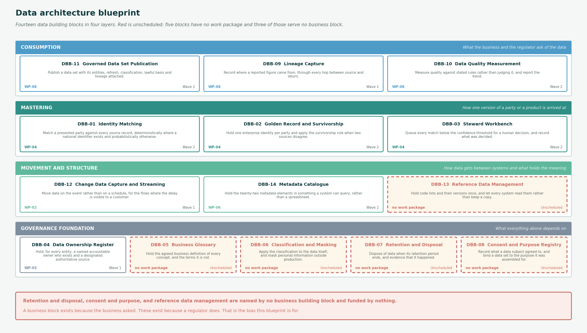
Figure 1 — The data architecture blueprint. Dashed and red is unscheduled: no work package funds it.

6. Findings
Five data building blocks have no work package, and three of them serve no business block either
Business glossary, classification and masking, retention and disposal, consent and purpose, and reference data management. The last three are named by no business building block.
A business block exists because the business asked for something. These exist because a regulator does, or because the estate cannot function coherently without them. Nothing in the roadmap funds any of the five, and that is the clearest thing this blueprint shows.
Retention and disposal is the largest unfunded exposure in the data architecture
DBB-07. Twenty-four entities carry a retention obligation under POPIA, FICA, FAIS, the Companies Act, the Insurance Act or IFRS 17. Nothing disposes of anything.
It has no gap in O29, no work package in O30 and no owner. It should either be added to the gap register or accepted explicitly by the Chief Risk Officer. It is currently neither.
Eight of fourteen blocks depend on the ownership register
DBB-04. It is Wave 1, costs R12.6m as part of WP-03, and carries no visible business benefit.
It is the foundation of the data architecture in the same way the integration platform is the foundation of the application architecture. Both are the packages most likely to be cut, and both make everything after them possible.
Identity is three blocks, not one
Matching, golden record and steward workbench. The business block ABB-01 names one capability; delivering it needs three mechanisms.
This is why the identity work is estimated at R96.4m rather than the cost of a matching engine. Presenting it as one thing is how it gets under-scoped.
The blocks with work packages are the ones with a business sponsor
Nine of fourteen map to WP-02, WP-03, WP-04 or WP-06. The five without are governance and compliance mechanisms.
That is a predictable bias rather than a failure of analysis. Naming it here is the only way it gets corrected at the roadmap gate rather than after an audit.

Referenced artifacts
- Architecture Definition Document — Data · Data Architecture baseline and target · Conceptual and Logical Data Model
- Data Lifecycle · Data Security · Master Data Model · Conceptual Metadata Model
- Information to Data Catalogue Traceability · Information Source Map · Data and Application Models
- Metamodel O29 Gap, O30 Work Package and O35 Business Building Block registers

